MODULE 1

Introduction – Number theory and basic cryptography

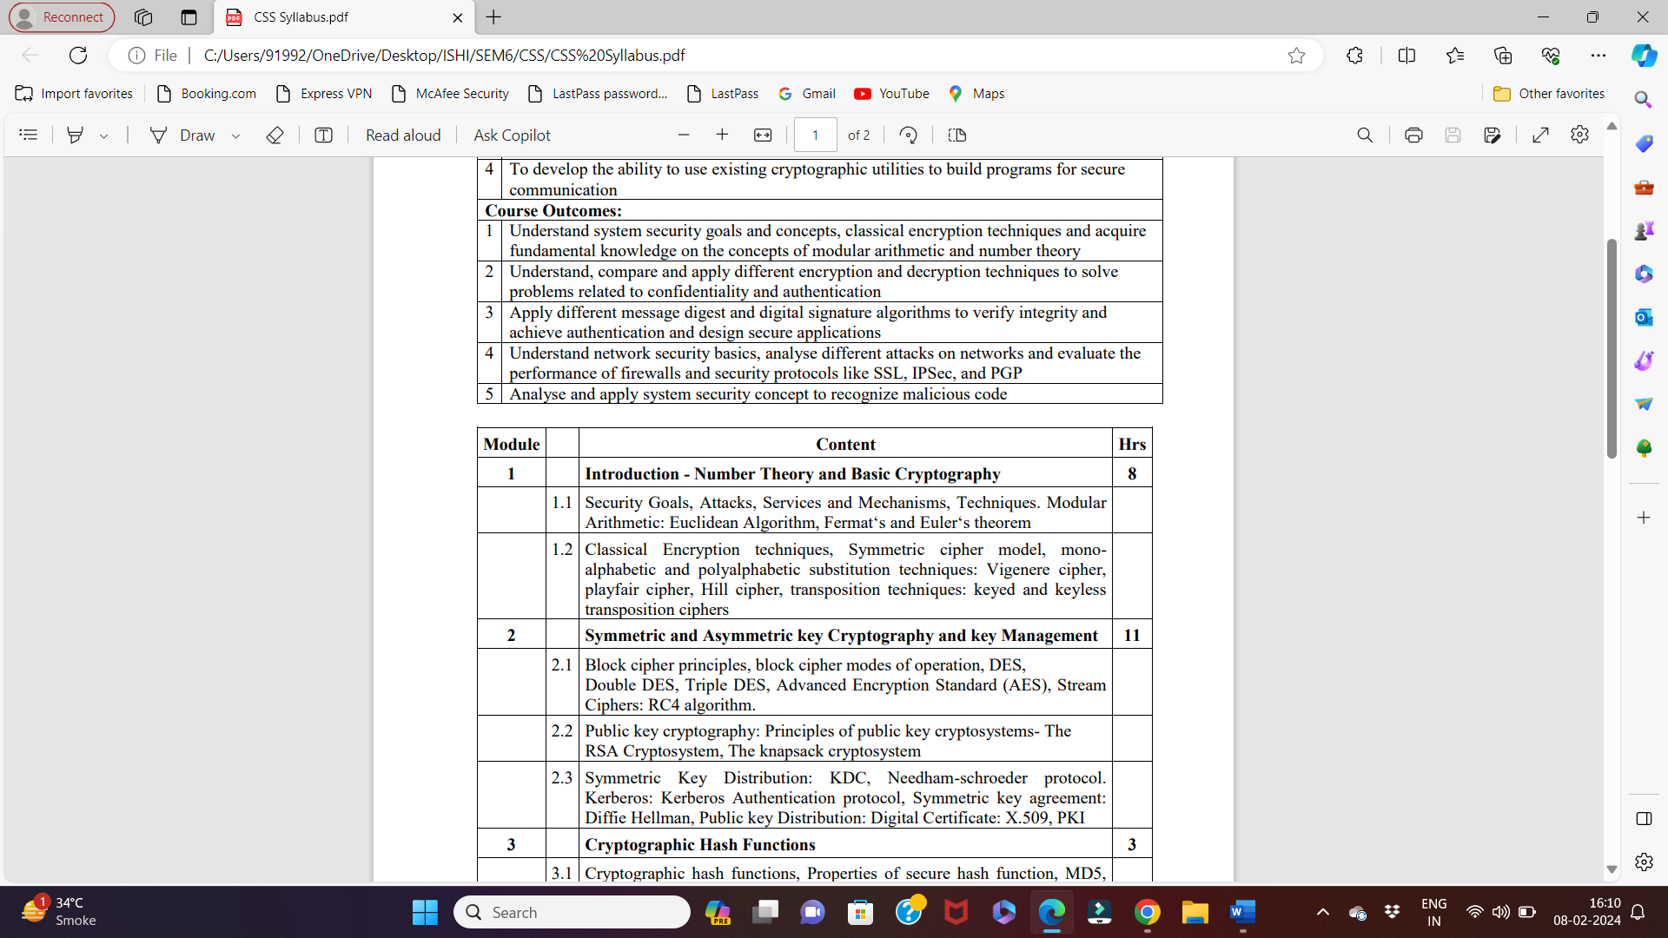

PYQ

Q. Use Hill Cipher to encrypt the text “short”. They key to be used is “hill”.(x2)

Q. Explain the relationship between Security Services and Mechanisms in detail.(x2)-IMP

In the context of cybersecurity and network security, Security Services and Security Mechanisms are closely related concepts that work together to protect data and communications. Here's a detailed explanation of their relationship:

### Security Services

Security Services are a set of functions or protocols designed to provide a certain level of security for data processing systems and communications. They are defined by the International Telecommunication Union (ITU) and include the following key services:

1. **Confidentiality**: Ensuring that information is not made available or disclosed to unauthorized individuals, entities, or processes.

2. **Integrity**: Protecting data from being altered or tampered with by unauthorized parties.

3. **Authentication**: Verifying the identity of entities involved in communication.

4. **Non-repudiation**: Preventing entities from denying their actions, ensuring that communication or transaction origins can be verified.

5. **Access Control**: Restricting access to resources to only those who are authorized.

6. **Availability**: Ensuring that data and services are available to authorized users when needed.

### Security Mechanisms

Security Mechanisms are the specific methods, tools, or techniques employed to provide the security services. They are the practical means to achieve the desired level of security. Key mechanisms include:

1. **Encryption**: Converts data into a coded form to prevent unauthorized access (supports Confidentiality).

2. **Digital Signatures**: Provides a way to verify the authenticity and integrity of a message or document (supports Authentication, Integrity, and Non-repudiation).

3. **Hash Functions**: Produces a fixed-size hash value from input data, which is used to verify data integrity (supports Integrity).

4. **Authentication Protocols**: Includes methods such as passwords, biometrics, and cryptographic keys to verify user identities (supports Authentication).

5. **Access Control Lists (ACLs)**: Lists that specify which users or system processes are granted access to objects and what operations are allowed (supports Access Control).

6. **Firewalls**: Monitors and controls incoming and outgoing network traffic based on predetermined security rules (supports Confidentiality, Integrity, and Access Control).

7. **Intrusion Detection Systems (IDS)**: Monitors networks or systems for malicious activities or policy violations (supports Availability and Integrity).

8. **Security Information and Event Management (SIEM)**: Provides real-time analysis of security alerts generated by applications and network hardware (supports Availability, Integrity, and Authentication).

### Relationship Between Security Services and Mechanisms

The relationship between Security Services and Mechanisms is synergistic and interdependent. Security Mechanisms are implemented to fulfill the objectives set by Security Services. For example:

- **Confidentiality Service**: Achieved through Encryption Mechanisms. Encryption algorithms like AES (Advanced Encryption Standard) ensure that even if data is intercepted, it cannot be read by unauthorized parties.

- **Integrity Service**: Ensured through Hash Functions and Digital Signatures. Hash functions generate unique hashes for data, and any alteration of data changes the hash, indicating tampering. Digital signatures further confirm that the data has not been altered since it was signed.

- **Authentication Service**: Provided by Authentication Protocols and Digital Signatures. Protocols like Kerberos or the use of multi-factor authentication ensure that users are who they claim to be.

- **Non-repudiation Service**: Supported by Digital Signatures. When a sender signs a document, they cannot later deny having sent it because the signature can be verified.

- **Access Control Service**: Enforced through ACLs, Firewalls, and Authentication Protocols. These mechanisms ensure that only authorized users can access specific resources.

- **Availability Service**: Maintained by Firewalls, IDS, and SIEM. These mechanisms detect and mitigate attacks like Denial of Service (DoS) that aim to make services unavailable.

### Example Scenario

Consider an online banking application:

- **Confidentiality**: The data exchanged between the client and server is encrypted using TLS (Transport Layer Security) to prevent eavesdropping.

- **Integrity**: Data integrity is ensured using hash functions. Any data alteration during transmission is detected.

- **Authentication**: Users are authenticated through multi-factor authentication, which might include a password and a biometric verification.

- **Non-repudiation**: Transactions are signed with a digital signature so that users cannot deny having initiated a transaction.

- **Access Control**: Role-based access controls ensure that only authorized employees can access sensitive parts of the banking system.

- **Availability**: The application employs firewalls and IDS to protect against attacks that could take the system offline.

In summary, Security Services define what security objectives need to be achieved, and Security Mechanisms are the tools and methods used to achieve these objectives. Their relationship is fundamental to building robust and effective security systems.

| **Security Service** | **Description** | **Associated Security Mechanisms** | **Examples** |
| --- | --- | --- | --- |
| **Confidentiality** | Ensuring that information is not disclosed to unauthorized entities. | Encryption | AES (Advanced Encryption Standard), TLS (Transport Layer Security) |
| **Integrity** | Protecting data from being altered or tampered with by unauthorized parties. | Hash Functions, Digital Signatures | SHA-256 (Secure Hash Algorithm 256-bit), MD5 (Message Digest Algorithm 5) |
| **Authentication** | Verifying the identity of entities involved in communication. | Authentication Protocols, Digital Signatures | Kerberos, Multi-Factor Authentication, Biometrics |
| **Non-repudiation** | Preventing entities from denying their actions. | Digital Signatures | RSA (Rivest-Shamir-Adleman), DSA (Digital Signature Algorithm) |
| **Access Control** | Restricting access to resources to authorized entities. | Access Control Lists (ACLs), Firewalls, Authentication Protocols | Role-Based Access Control (RBAC), IPtables, OAuth |
| **Availability** | Ensuring that data and services are available to authorized users when needed. | Firewalls, Intrusion Detection Systems (IDS), Security Information and Event Management (SIEM) | Snort (IDS), Splunk (SIEM), Denial of Service (DoS) protections |

| **Security Service** | **Description** | **Associated Security Mechanisms** | **Example Implementation in Online Banking** |
| --- | --- | --- | --- |
| **Confidentiality** | Ensuring data privacy during transmission. | Encryption | TLS to encrypt data between client and server |
| **Integrity** | Ensuring data is not tampered with during transmission. | Hash Functions | SHA-256 to verify data integrity |
| **Authentication** | Verifying user identity. | Authentication Protocols, Multi-Factor Authentication | Passwords combined with biometric verification |
| **Non-repudiation** | Ensuring users cannot deny their transactions. | Digital Signatures | RSA digital signatures for transaction verification |
| **Access Control** | Restricting access to authorized users. | ACLs, Role-Based Access Control (RBAC) | Employees only accessing sensitive parts of the system based on their role |
| **Availability** | Ensuring the system is available to users. | Firewalls, IDS, SIEM | Firewalls and IDS to prevent and detect DoS attacks |

**Example Scenario: Online Banking Application**

Q. State the rules for finding Euler’s phi function. Calculate a. φ(11) b. φ(49) c.φ(240)

Q. Explain with examples keyed and keyless transposition ciphers-IMP

Transposition ciphers are a type of encryption method where the positions of the characters in the plaintext are shifted according to a certain system to form the ciphertext. They are generally categorized into keyed and keyless transposition ciphers. Here’s an explanation with examples for both types:

### Keyless Transposition Ciphers

In keyless transposition ciphers, the transposition of characters follows a regular, fixed system that does not depend on a key.

#### Example: Simple Columnar Transposition

A simple columnar transposition involves writing the plaintext in rows of a fixed length and then reading the columns in a specified order.

**Plaintext**: "WE ARE DISCOVERED FLEE AT ONCE"

1. Write the plaintext in rows of a fixed length, for instance, 5 characters per row:

```

WEARE

DISCO

VERED

FLEEA

TONCE

2. Read the columns to form the ciphertext:

**Ciphertext**: "WDFTAEILTOERESOERCNVDEEA"

- Column 1: W, D, V, F, T -> WDFVT

- Column 2: E, I, E, L, O -> EILEO

- Column 3: A, S, R, E, N -> ASREN

- Column 4: R, C, E, E, C -> RCEEC

- Column 5: E, O, D, A, E -> EODAE

Concatenate the columns to get the ciphertext: "WDFVTEILEOASRENRCEECEOADAE".

### Keyed Transposition Ciphers

In keyed transposition ciphers, the transposition follows a pattern determined by a key.

#### Example: Columnar Transposition with a Key

1. Choose a keyword, e.g., "ZEBRAS".

2. Number the columns based on the alphabetical order of the keyword's letters:

```

Z E B R A S

5 3 2 4 1 6

```

3. Write the plaintext in rows under these columns:

**Plaintext**: "WE ARE DISCOVERED FLEE AT ONCE"

```

5 3 2 4 1 6

Z E B R A S

-----------

W E A R E

D I S C O

V E R E D

F L E E A

T O N C E

```

4. Rearrange columns based on the numerical order of the keyword:

```

1 2 3 4 5 6

A B E R Z S

E A E R W E

O S I C D O

C R E E V E

N C E E F L

T L O E F A

```

5. Read the columns vertically to form the ciphertext:

**Ciphertext**: "EVLNACDROAESOEEWFCIRRALEET"

- Column 1 (A): E, E, O, C, N, T -> EEOCNT

- Column 2 (B): A, A, S, R, C, L -> AASRCL

- Column 3 (E): E, I, E, E, E, O -> EIEECO

- Column 4 (R): R, C, R, E, E, E -> RCREEE

- Column 5 (Z): W, D, V, E, F, F -> WDVFFF

- Column 6 (S): E, O, D, A, E, L -> EODAEL

Concatenate the columns to get the ciphertext: "EIEECORECOFAEWFLRREEVDDFT".

### Summary

- **Keyless Transposition Cipher**: The order of transposition is fixed and does not rely on a key. For example, writing plaintext in rows of fixed length and reading it column-wise.

- **Keyed Transposition Cipher**: The order of transposition is determined by a keyword, which provides additional security. For example, columnar transposition cipher where the order of columns is decided by the alphabetical order of the keyword.

Both types of ciphers rearrange the characters of the plaintext to create the ciphertext, but keyed transposition ciphers offer more complexity and security due to the use of a key.

Q. State the rules for finding Euler’s phi function. Calculate a. φ(10) b. φ(49) c.φ(343)

Q. Define goals of security and mechanism to achieve them.(X2)

The goals of security, often referred to as the principles of information security, are aimed at ensuring the protection of data and systems from threats. The primary goals are Confidentiality, Integrity, Availability, Authentication, Non-repudiation, and Access Control. Each of these goals is achieved through specific mechanisms. Here's a detailed breakdown:

**Goals of Security and Mechanisms to Achieve Them**

1. **Confidentiality**
   * **Definition**: Ensuring that information is not disclosed to unauthorized individuals, entities, or processes.
   * **Mechanisms**:
     + **Encryption**: Converts data into a coded format that is unreadable without a decryption key. Example: AES (Advanced Encryption Standard), RSA.
     + **Access Controls**: Ensures only authorized users have access to sensitive data. Example: Role-Based Access Control (RBAC), Attribute-Based Access Control (ABAC).
     + **Steganography**: Hides the existence of the data. Example: Embedding text within an image file.
2. **Integrity**
   * **Definition**: Ensuring that information is accurate and has not been altered by unauthorized individuals.
   * **Mechanisms**:
     + **Hash Functions**: Generates a fixed-size hash value from data to detect any changes. Example: SHA-256, MD5.
     + **Digital Signatures**: Verifies the origin and integrity of a message. Example: RSA Digital Signature.
     + **Checksums and Cyclic Redundancy Checks (CRC)**: Used to detect errors in data transmission.
3. **Availability**
   * **Definition**: Ensuring that information and resources are available to authorized users when needed.
   * **Mechanisms**:
     + **Redundancy**: Using backup components to ensure system availability in case of failure. Example: RAID (Redundant Array of Independent Disks), server clustering.
     + **DDoS Protection**: Techniques to prevent Distributed Denial of Service attacks. Example: Rate limiting, Web Application Firewalls (WAFs).
     + **Regular Maintenance and Patching**: Keeping systems updated to prevent downtime due to vulnerabilities.
4. **Authentication**
   * **Definition**: Verifying the identity of users and systems.
   * **Mechanisms**:
     + **Passwords and PINs**: Traditional methods for user authentication.
     + **Biometrics**: Using unique biological characteristics for identification. Example: Fingerprint scanning, facial recognition.
     + **Multi-Factor Authentication (MFA)**: Combining two or more authentication factors. Example: Password + SMS code, Password + fingerprint.
5. **Non-repudiation**
   * **Definition**: Ensuring that a party cannot deny the authenticity of their signature on a document or a message that they originated.
   * **Mechanisms**:
     + **Digital Signatures**: Provides proof of the origin and integrity of data, preventing denial of participation. Example: RSA, DSA (Digital Signature Algorithm).
     + **Audit Logs**: Records of activities that can be used to verify actions taken by users.
6. **Access Control**
   * **Definition**: Restricting access to resources to only those who are authorized.
   * **Mechanisms**:
     + **Access Control Lists (ACLs)**: Specifies which users or system processes can access resources and what operations they can perform. Example: File system permissions.
     + **Role-Based Access Control (RBAC)**: Assigns permissions to users based on their role within an organization. Example: Different access rights for administrators and regular users.
     + **Mandatory Access Control (MAC)**: System-enforced access control based on security labels. Example: Classified information in government systems.

**Summary Table**

| **Security Goal** | **Definition** | **Mechanisms** |
| --- | --- | --- |
| **Confidentiality** | Ensuring information is not disclosed to unauthorized entities. | Encryption (AES, RSA), Access Controls (RBAC, ABAC), Steganography |
| **Integrity** | Ensuring information is accurate and not altered. | Hash Functions (SHA-256, MD5), Digital Signatures (RSA), Checksums, CRC |
| **Availability** | Ensuring resources are available when needed. | Redundancy (RAID, server clustering), DDoS Protection (rate limiting, WAFs), Patching |
| **Authentication** | Verifying the identity of users and systems. | Passwords, Biometrics (fingerprint scanning), Multi-Factor Authentication (MFA) |
| **Non-repudiation** | Ensuring participation cannot be denied. | Digital Signatures (RSA, DSA), Audit Logs |
| **Access Control** | Restricting access to authorized entities. | Access Control Lists (ACLs), Role-Based Access Control (RBAC), Mandatory Access Control (MAC) |

These goals and mechanisms form the foundation of a robust security architecture, ensuring that information and systems are protected from a wide range of threats.

Q.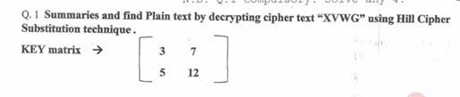

Q. Encrypt “academic committee will meet today” using Playfair cipher with keyword “ROYAL ENFIELD”

Q. Enlist security goals. Discuss their significance.

**Security Goals and Their Significance**

1. **Confidentiality**
2. **Integrity**
3. **Availability**
4. **Authentication**
5. **Non-repudiation**
6. **Access Control**

**Significance of Each Security Goal**

1. **Confidentiality**
   * **Definition**: Ensuring that information is not disclosed to unauthorized individuals, entities, or processes.
   * **Significance**:
     + **Protection of Sensitive Information**: Confidentiality is crucial for protecting sensitive information such as personal data, financial records, and intellectual property from unauthorized access and disclosure.
     + **Maintaining Privacy**: It helps maintain user privacy, which is essential for compliance with laws and regulations such as GDPR (General Data Protection Regulation) and HIPAA (Health Insurance Portability and Accountability Act).
     + **Trust and Reputation**: Ensuring confidentiality helps maintain trust between individuals and organizations, thereby protecting the reputation of the entity responsible for the information.
2. **Integrity**
   * **Definition**: Ensuring that information is accurate and has not been altered by unauthorized individuals.
   * **Significance**:
     + **Data Accuracy and Reliability**: Integrity ensures that data remains accurate, complete, and reliable, which is vital for decision-making processes and operational activities.
     + **Prevention of Fraud and Errors**: It helps prevent unauthorized modifications, which could lead to fraud, errors, or malicious activities.
     + **Compliance and Accountability**: Maintaining data integrity is often a regulatory requirement, ensuring compliance with standards and laws.
3. **Availability**
   * **Definition**: Ensuring that information and resources are available to authorized users when needed.
   * **Significance**:
     + **Operational Continuity**: Availability is crucial for the uninterrupted operation of services and systems, ensuring that users can access the information and resources they need.
     + **Customer Satisfaction**: High availability leads to better user experiences and customer satisfaction, especially in services requiring 24/7 access.
     + **Business Resilience**: It supports business resilience by ensuring that critical services and operations can continue even in the face of disruptions such as hardware failures, natural disasters, or cyber-attacks.
4. **Authentication**
   * **Definition**: Verifying the identity of users and systems.
   * **Significance**:
     + **Access Control**: Authentication is the first line of defense in controlling access to systems and data, ensuring that only authorized individuals can access certain resources.
     + **Security Enforcement**: It supports the enforcement of other security measures by confirming the identities of users and systems involved in a transaction or communication.
     + **Trust Building**: Effective authentication mechanisms build trust between parties by verifying identities and preventing impersonation and unauthorized access.
5. **Non-repudiation**
   * **Definition**: Ensuring that a party cannot deny the authenticity of their signature on a document or a message that they originated.

| **Security Goal** | **Significance** |
| --- | --- |
| **Confidentiality** | Protects sensitive information, maintains privacy, builds trust. |
| **Integrity** | Ensures data accuracy and reliability, prevents fraud, supports compliance. |
| **Availability** | Ensures operational continuity, enhances customer satisfaction, supports business resilience. |
| **Authentication** | Controls access, enforces security, builds trust. |
| **Non-repudiation** | Provides accountability, legal assurance, aids in dispute resolution. |
| **Access Control** | Protects resources, minimizes security risks, ensures regulatory compliance. |

* + **Significance**:
    - **Accountability**: Non-repudiation ensures that parties in a transaction cannot deny their actions, providing a clear trail of accountability.
    - **Legal and Contractual Assurance**: It is essential for legal and contractual purposes, where proof of origin and delivery of information is required.
    - **Dispute Resolution**: Non-repudiation helps resolve disputes by providing evidence of actions and communications, thus supporting enforcement of agreements and transactions.

1. **Access Control**
   * **Definition**: Restricting access to resources to only those who are authorized.
   * **Significance**:
     + **Resource Protection**: Access control protects resources such as data, systems, and networks from unauthorized access and use.
     + **Minimization of Security Risks**: By limiting access to only those who need it, access control reduces the risk of data breaches, misuse, and other security incidents.
     + **Regulatory Compliance**: Many regulations require strict access controls to protect sensitive information and ensure that only authorized personnel can access certain types of data.

Each security goal plays a vital role in creating a comprehensive and effective security posture. Together, they ensure the protection, reliability, and proper use of information and systems. Here’s a summarized significance of each goal:

These goals collectively contribute to a robust security framework that is essential for safeguarding information and ensuring the smooth functioning of modern digital systems.

Q. Use the playfair cipher with the keyword: “HEALTH” to encipher the message “Life is full of Surprises”(10M)

AARTI:

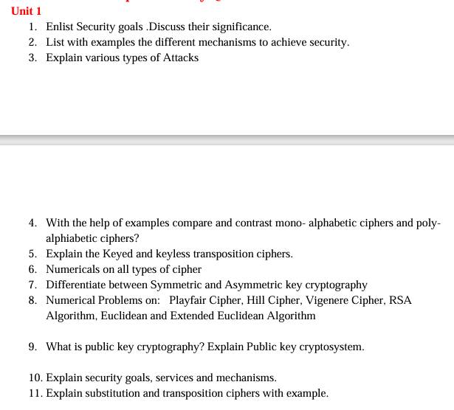

IMP:

Q. What are traditional ciphers? Discuss any one substitution and transposition cipher with example. List their merits and demerits

### Traditional Ciphers

Traditional ciphers are encryption methods used to secure information before the advent of modern computer-based cryptography. They can be broadly classified into two types: substitution ciphers and transposition ciphers.

1. **Substitution Ciphers**: These ciphers replace elements of the plaintext with other symbols or groups of symbols. The most common forms are monoalphabetic substitution ciphers (each letter of the plaintext is replaced with a corresponding letter of the ciphertext alphabet) and polyalphabetic substitution ciphers (multiple substitution alphabets are used).

2. **Transposition Ciphers**: These ciphers rearrange the positions of the characters in the plaintext according to a specific system, without changing the characters themselves.

### Substitution Cipher: Caesar Cipher

**Caesar Cipher Example**:

- **Plaintext**: HELLO

- **Key**: 3 (each letter is shifted by 3 positions in the alphabet)

- **Ciphertext**: KHOOR

**Encryption Process**:

1. Each letter in the plaintext is shifted by a fixed number of positions down the alphabet.

2. For the Caesar cipher with a key of 3:

- H -> K

- E -> H

- L -> O

- L -> O

- O -> R

**Decryption Process**:

- To decrypt, shift each letter in the ciphertext by the same number of positions up the alphabet.

- For ciphertext "KHOOR" with a key of 3:

- K -> H

- H -> E

- O -> L

- O -> L

- R -> O

**Merits**:

- **Simplicity**: Easy to understand and implement.

- **Speed**: Fast encryption and decryption processes.

**Demerits**:

- **Weak Security**: Vulnerable to frequency analysis and brute force attacks due to the limited number of possible keys (25 in the case of the Caesar cipher).

- **Pattern Retention**: The same letters in plaintext will always result in the same letters in ciphertext, making it easier to detect patterns.

### Transposition Cipher: Columnar Transposition

**Columnar Transposition Cipher Example**:

- **Plaintext**: WE ARE DISCOVERED FLEE AT ONCE

- **Key**: ZEBRAS (determines the order in which columns are read)

**Encryption Process**:

1. Write the plaintext in rows under columns labeled with the keyword, in this case, "ZEBRAS".

2. Rearrange columns based on the alphabetical order of the keyword.

3. Read the columns in the rearranged order to form the ciphertext.

**Steps**:

1. Arrange plaintext in a grid with columns labeled by the keyword:

```

Z E B R A S

-----------

W E A R E

D I S C O

V E R E D

F L E E A

T O N C E

```

2. Number the columns based on the alphabetical order of the keyword:

```

Z E B R A S

5 3 2 4 1 6

```

3. Rearrange columns based on numerical order:

```

A B E R Z S

E A E R W E

O S I C D O

C R E E V E

N C E E F L

T L O E F A

```

4. Read columns vertically to get the ciphertext:

**Ciphertext**: "EWEAEOESIACRDOCREVETFOFNL"

**Merits**:

- **Pattern Disruption**: More resistant to frequency analysis as it only rearranges characters.

- **Complexity**: Increased complexity over simple substitution ciphers.

**Demerits**:

- **Key Management**: Requires the secure management and exchange of the key.

- **Vulnerability**: Still susceptible to certain forms of cryptanalysis, such as transposition analysis and known-plaintext attacks.

- **Message Length Dependency**: Efficiency depends on the length of the message and the key; padding may be required for shorter messages.

### Summary

Traditional ciphers such as substitution and transposition ciphers form the basis of classical cryptography. While the Caesar cipher is a straightforward substitution cipher with simplicity and speed, its security is weak. On the other hand, columnar transposition ciphers offer more complexity and better resistance to simple attacks but require key management and can still be vulnerable to more advanced cryptanalytic techniques. Understanding their merits and demerits helps in appreciating the evolution of modern cryptographic methods.

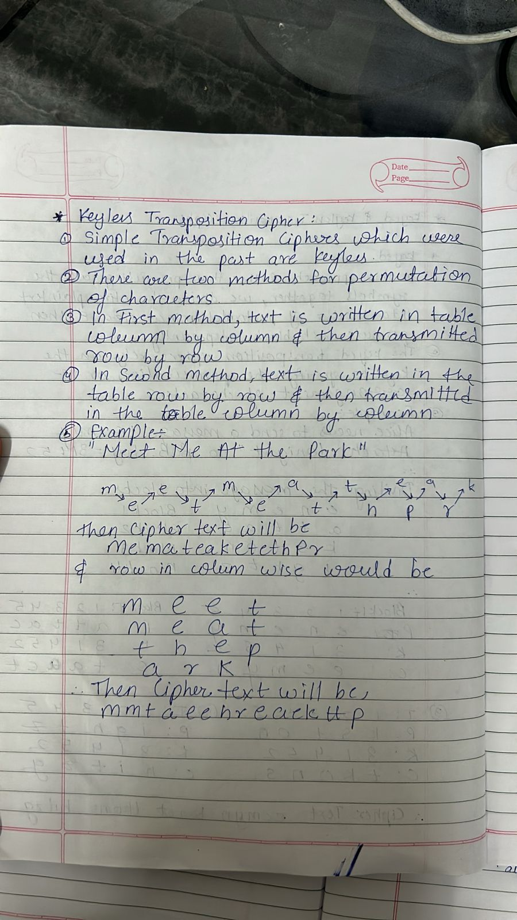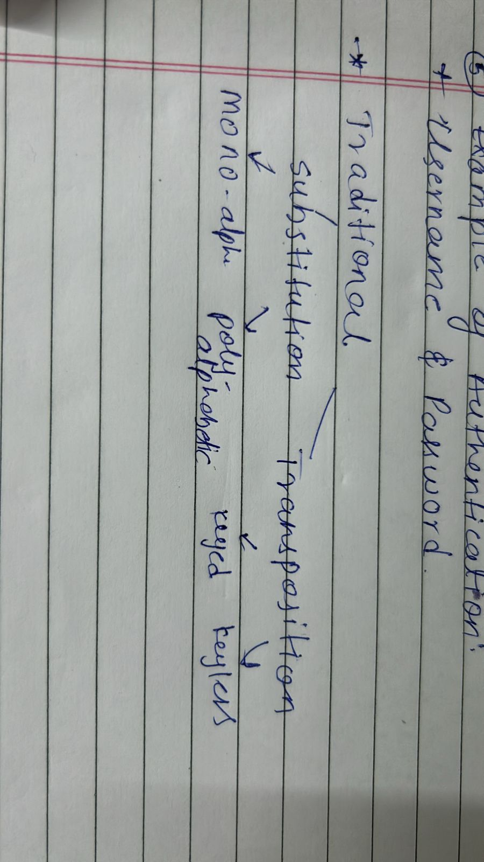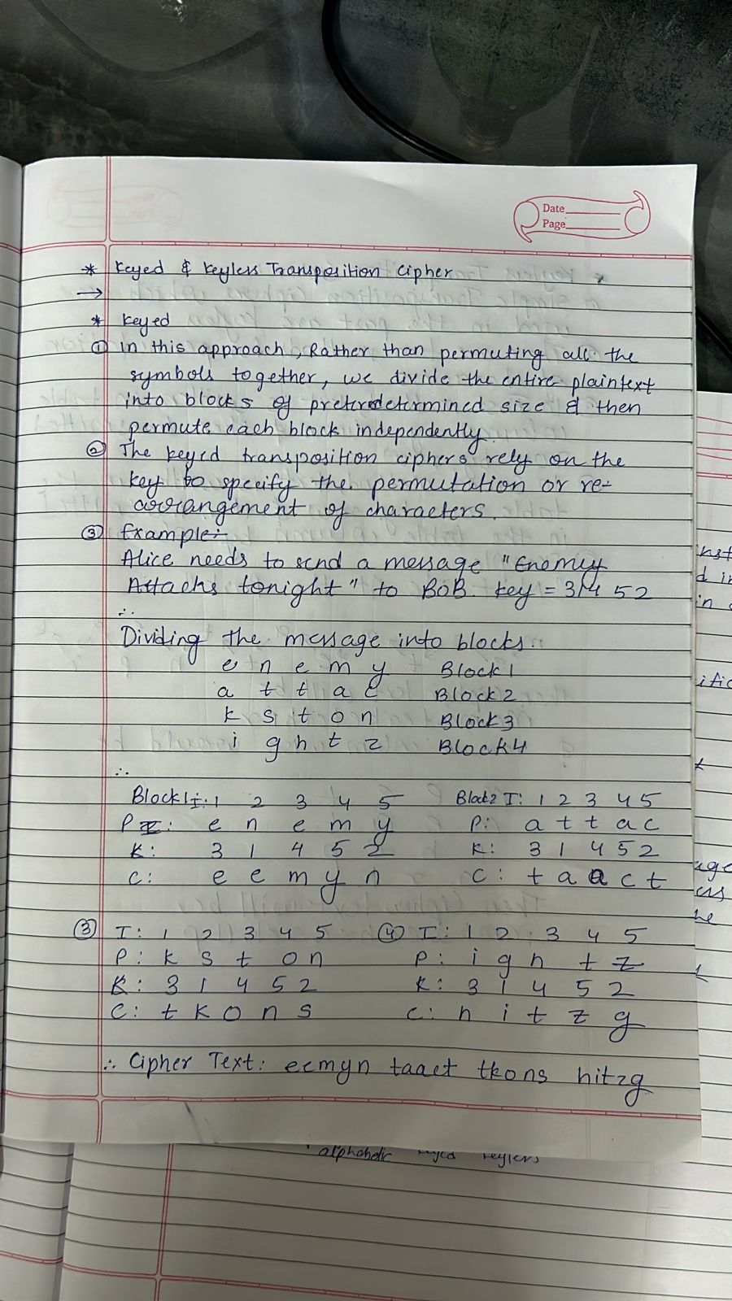

Q. Numericals on : Playfair , hill , auto key , affine cipher

q. State the rules for finding Euler’s phi function and numerical on it

Q. Explain security goals, services , mechanism OR Relation between security services and mechanism

Cryptography is the science of securing communication and information through the use of mathematical techniques and algorithms.

Definition: The protection afforded to an automated information system in order to attain the applicable objectives of preserving the integrity , availability and confidentiality of information system resources (includes hardware , software , firmware , information/data and telecommunications)

Need for network security :

Network security is crucial in today's interconnected world where information is constantly exchanged over networks. Here are some key reasons why network security is essential:

1. **Protection Against Unauthorized Access:**

- Network security helps prevent unauthorized access to sensitive data and resources. Unauthorized access could lead to data breaches, identity theft, or the compromise of critical systems.

2. **Confidentiality of Data:**

- Network security measures ensure the confidentiality of data by encrypting information as it travels across networks. This safeguards sensitive information from being intercepted and understood by unauthorized parties.

3. **Integrity of Data:**

- Network security mechanisms, such as checksums and digital signatures, ensure the integrity of data. This helps detect any unauthorized modifications or tampering with transmitted information.

4. **Prevention of Malware and Viruses:**

- Network security solutions include firewalls, antivirus software, and intrusion detection/prevention systems to defend against malware and viruses. These threats can disrupt operations, steal data, or damage systems.

5. **Availability of Resources:**

- Network security helps maintain the availability of network resources. Denial-of-service (DoS) attacks and other malicious activities can attempt to overwhelm systems and disrupt services. Security measures aim to mitigate these risks.

6. **Protection Against Data Loss:**

- Secure networks include measures to prevent data loss. This may involve regular backups, secure storage practices, and controls to prevent accidental or intentional data deletion or corruption.

7. **Compliance with Regulations:**

- Many industries and organizations are subject to regulations and compliance requirements regarding the protection of sensitive information. Implementing robust network security measures helps meet these standards and avoid legal consequences.

8. **Securing Communication Channels:**

- Network security ensures that communication channels, whether wired or wireless, are secure. This is essential for protecting sensitive information as it travels between devices and across the internet.

9. **Safeguarding Against Social Engineering Attacks:**

- Network security includes educating users about social engineering threats, such as phishing attacks. Users are often the first line of defense, and awareness training is crucial for preventing security breaches.

10. **Protection of Critical Infrastructure:**

- Critical infrastructure, such as power grids, financial systems, and healthcare networks, relies heavily on secure and resilient networks. Network security is vital to safeguard these essential services from cyber threats.

11. **Mitigation of Insider Threats:**

- Network security measures help detect and mitigate insider threats, whether intentional or accidental. This includes monitoring user activities, restricting access based on roles, and implementing least privilege principles.

In summary, network security is essential for protecting the confidentiality, integrity, and availability of information and resources in the digital age. It involves a combination of technological solutions, policies, and user awareness to create a robust defense against a wide range of cyber threats.

Security Goals : CIA triad

Confidentiality : prevent unauthorized access and disclosure , protect the data that is being transmitted

* Confidentiality is equivalent to privacy, we need to protect our confidential information(s).
* Confidentiality involves protection of information by providing access of information to allowed users and disallowing others.
* Confidentiality can be achieved through:

1. Encryption 2. Access Control 3. Authentication 4. Authorization

Example : Account Information

Integrity: sent message = received message

ensure that there is no modification of the message that is being transmitted , whatever the sender is sending the same message the receiver should receive and if there is any modification in the message that is being transmitted the system should be able to find out that and it should discard that message

* Integrity refers to ensuring that data is real, accurate and safeguarded from unauthorized user modification.
* Integrity gives the assurance that the information received is exact and accurate.

Example : Patients information

Availability : ensure timely and reliable access to the user

* Availability is the property in which information is accessible and modifiable in a timely fashion by those authorized to do so.
* It is the guarantee of reliable and constant access to our sensitive data by authorized people.

Example : Authentication service

Additional to CIA triad :

Authenticity : being genuine and being able to verify the parties involved

Accountability : every user that accesses the system should have some responsibilities

The CIA Triad is a fundamental concept in information security that represents three core principles to be addressed in order to ensure the security of information and information systems. The three principles are Confidentiality, Integrity, and Availability, often abbreviated as the CIA Triad:

1. **Confidentiality:**

- Confidentiality ensures that information is only accessible to authorized individuals, entities, or systems. The goal is to prevent unauthorized access, disclosure, or exposure of sensitive data. Encryption, access controls, and secure communication protocols are examples of measures used to maintain confidentiality.

2. **Integrity:**

- Integrity refers to the accuracy, consistency, and trustworthiness of data. The objective is to prevent unauthorized or unintentional modifications, alterations, or deletions of information. Measures such as checksums, digital signatures, and access controls help maintain data integrity.

3. **Availability:**

- Availability focuses on ensuring that information and resources are accessible and usable when needed by authorized users. This includes protection against denial-of-service attacks, system failures, or other disruptions that could impact the availability of services. Redundancy, backups, and disaster recovery plans are common strategies to enhance availability.

The CIA Triad provides a comprehensive framework for understanding and addressing the security goals and challenges within an organization or system. By considering confidentiality, integrity, and availability in the design, implementation, and management of information systems, security professionals can develop a more robust and balanced approach to information security.

It's important to note that while the CIA Triad is a foundational concept, additional principles and considerations, such as authentication, non-repudiation, and accountability, are often integrated into broader security frameworks to provide a more holistic approach to information security.

Certainly! Let's delve further into a real-world scenario involving an online banking system to illustrate how the principles of the CIA Triad—Confidentiality, Integrity, and Availability—can be applied.

**Real-World Scenario: Online Banking System**

1. **Confidentiality:**

- **Implementation:** Encryption plays a crucial role in maintaining the confidentiality of sensitive customer data.

- **Example:** When a customer logs in to the online banking platform, their username, password, and any other sensitive information are encrypted using secure protocols (e.g., TLS/SSL) during transmission. This ensures that even if intercepted, the data remains unreadable without the proper decryption key.

2. **Integrity:**

- **Implementation:** Measures such as digital signatures and hash functions are used to verify the integrity of transactions and account information.

- **Example:** When a customer initiates a funds transfer, the transaction details are digitally signed to create a unique signature. The recipient bank can then verify the signature to ensure that the transaction has not been altered in transit. Additionally, hash functions may be applied to stored data to detect any unauthorized modifications.

3. **Availability:**

- **Implementation:** Redundancy, load balancing, and disaster recovery plans are employed to ensure continuous access to banking services.

- **Example:** Multiple servers are deployed to handle user requests, and load balancing distributes traffic across these servers. In the event of a server failure, the load is automatically shifted to functioning servers. Redundant data centers and backup systems are in place to provide seamless service even during unexpected events such as natural disasters or hardware failures.

4. **Additional Considerations:**

- **Authentication:** Strong authentication mechanisms, such as multi-factor authentication (MFA), are implemented to verify the identity of users.

- **Non-Repudiation:** Digital signatures can also serve the purpose of non-repudiation, ensuring that customers cannot deny authorizing transactions.

- **Accountability:** User activities are logged, providing accountability for actions within the system. This information is valuable for auditing and investigation purposes.

5. **Balancing the Triad:**

- **Example:** While implementing strong encryption (confidentiality), the system must balance the need for stringent access controls (confidentiality) with providing convenient and timely access to authorized users (availability).

6. **User Education:**

- **Example:** The bank conducts regular awareness programs to educate customers about phishing threats and the importance of keeping login credentials confidential. This proactive approach enhances both confidentiality and integrity by reducing the risk of unauthorized access.

In summary, in the context of an online banking system, the CIA Triad helps create a secure and reliable environment for customers to conduct transactions. Confidentiality protects sensitive data, integrity ensures the accuracy and trustworthiness of transactions, and availability ensures uninterrupted access to banking services. Combining these principles with additional security measures creates a robust defense against various cyber threats and contributes to building trust with customers.

Levels of impact of security breach :

Low Medium High

The impact of a security breach can vary widely depending on the nature and scope of the incident. Generally, the impact can be categorized into different levels, considering factors such as the extent of damage, the sensitivity of compromised information, and the consequences for individuals or organizations. Here are three common levels of impact associated with a security breach:

1. **Low Impact:**

- **Characteristics:**

- Limited or no access to sensitive data.

- Minimal disruption to operations.

- Isolated incidents with low potential for harm.

- **Examples:**

- Unauthorized access to non-sensitive information with no critical consequences.

- Low-level phishing attempts that are promptly detected and mitigated.

- Limited exposure of non-confidential data.

2. **Moderate Impact:**

- **Characteristics:**

- Compromise of moderately sensitive information.

- Some disruption to normal operations.

- Potential harm to individuals or the organization.

- **Examples:**

- Breach involving personally identifiable information (PII) such as names and addresses.

- Successful phishing attacks leading to unauthorized access to user accounts.

- Temporary disruption of services or systems.

3. **High Impact:**

- **Characteristics:**

- Severe compromise of sensitive and confidential information.

- Significant disruption to critical operations.

- Serious harm to individuals, reputation, or financial well-being.

- **Examples:**

- Data breaches exposing highly sensitive information (e.g., financial records, health records).

- Advanced persistent threats leading to prolonged unauthorized access and data exfiltration.

- Cyberattacks causing extended downtime, financial losses, or reputational damage.

4. **Factors Influencing Impact:**

- **Type of Data Compromised:** The sensitivity of the compromised data, such as financial records, healthcare information, or intellectual property, significantly influences the impact.

- **Duration of Unauthorized Access:** The longer an attacker remains undetected within a system, the greater the potential impact as they can exfiltrate more data or cause more damage over time.

- **Regulatory and Legal Consequences:** Breaches involving non-compliance with data protection regulations may lead to severe legal and financial consequences, amplifying the overall impact.

- **Reputation Damage:** The impact on an organization's reputation can be substantial, affecting customer trust and loyalty.

- **Financial Losses:** Beyond direct costs associated with a breach, there may be indirect financial losses due to business disruption, legal fees, and recovery efforts.

It's essential for organizations to assess the potential impact of a security breach and implement proactive measures to prevent, detect, and respond to such incidents. This includes robust cybersecurity practices, incident response plans, employee training, and continuous monitoring to mitigate the impact and protect sensitive information.

Threats and attacks

Threat : A potential for violation of security , which exists when there is a circumstance , capability , action or event that could breach security and cause harm. That is , a threat is a possible danger that might exploit a vulnerability.

Attack : An assault on system security that derives from an intelligent threat ; that is , an intelligent act that is a deliberate attempt (especially in the sense of a method or technique) to evade security services and violate the security policy of a system.

The OSI Security Architecture : it deals with

security attack , security mechanism , security service

Security attack : Action that compromises the security : Passive , active

Security mechanism : to detect , prevent or recover from a security attack. security mechanism should be active as well as passive :

Encipherment , digital signature , access control , data integrity , authentication exchange , traffic padding , routing control and notarization

Security service : Enhances the security , counter security attacks , and provide the service : Authentication , access control , data confidentiality , data integrity and nonrepudiation

SECURITY ATTACK;

Action that compromises the security of an individual or an organisation

Types: passive attack and active attack

Passive attack : Attempts to learn or make use of information from the system , unauthorized reading of messages and no modification involved

Does not affect system resources

Eavesdropping or monitoring of transmissions

Goal : obtain information that is being transmitted

Types: release of message content , traffic analysis

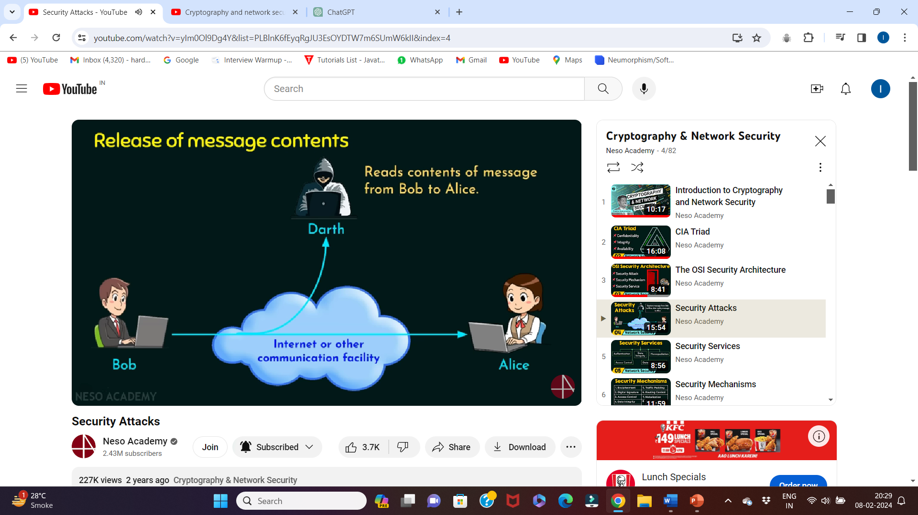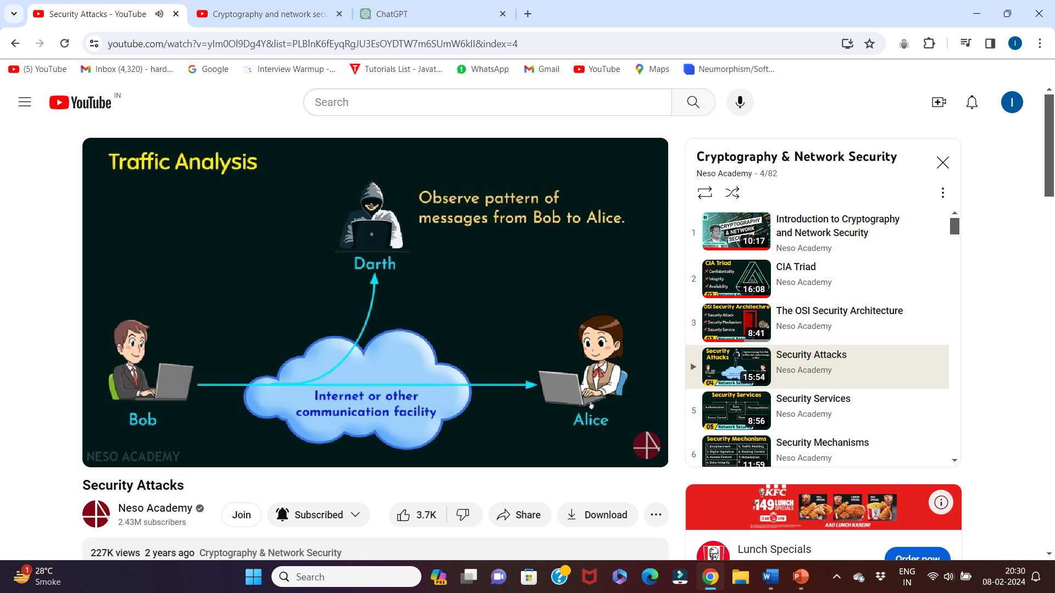Active attacks : It involves some modification of the data stream or the creation of a false stream

Subdivided into four categories :

* Masquerade - one entity pretends to be another
* Replay
* Modification of messages
* Denial of service(DoS)

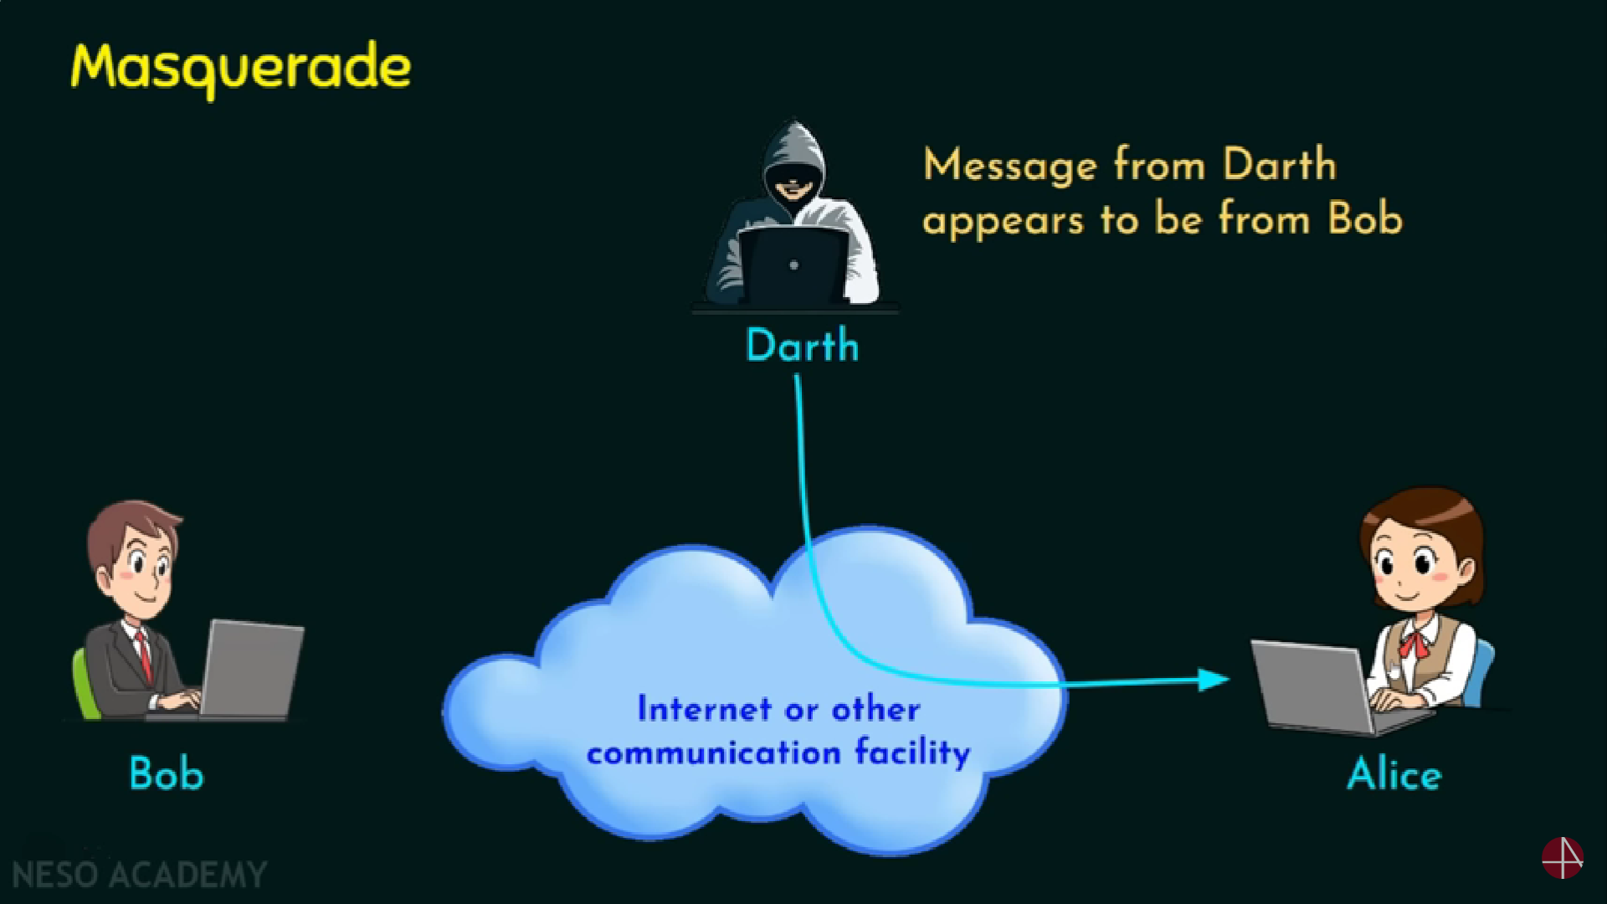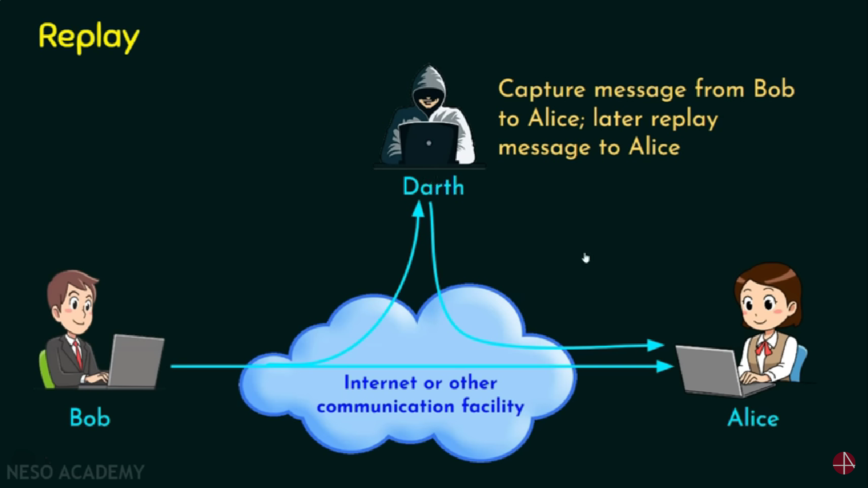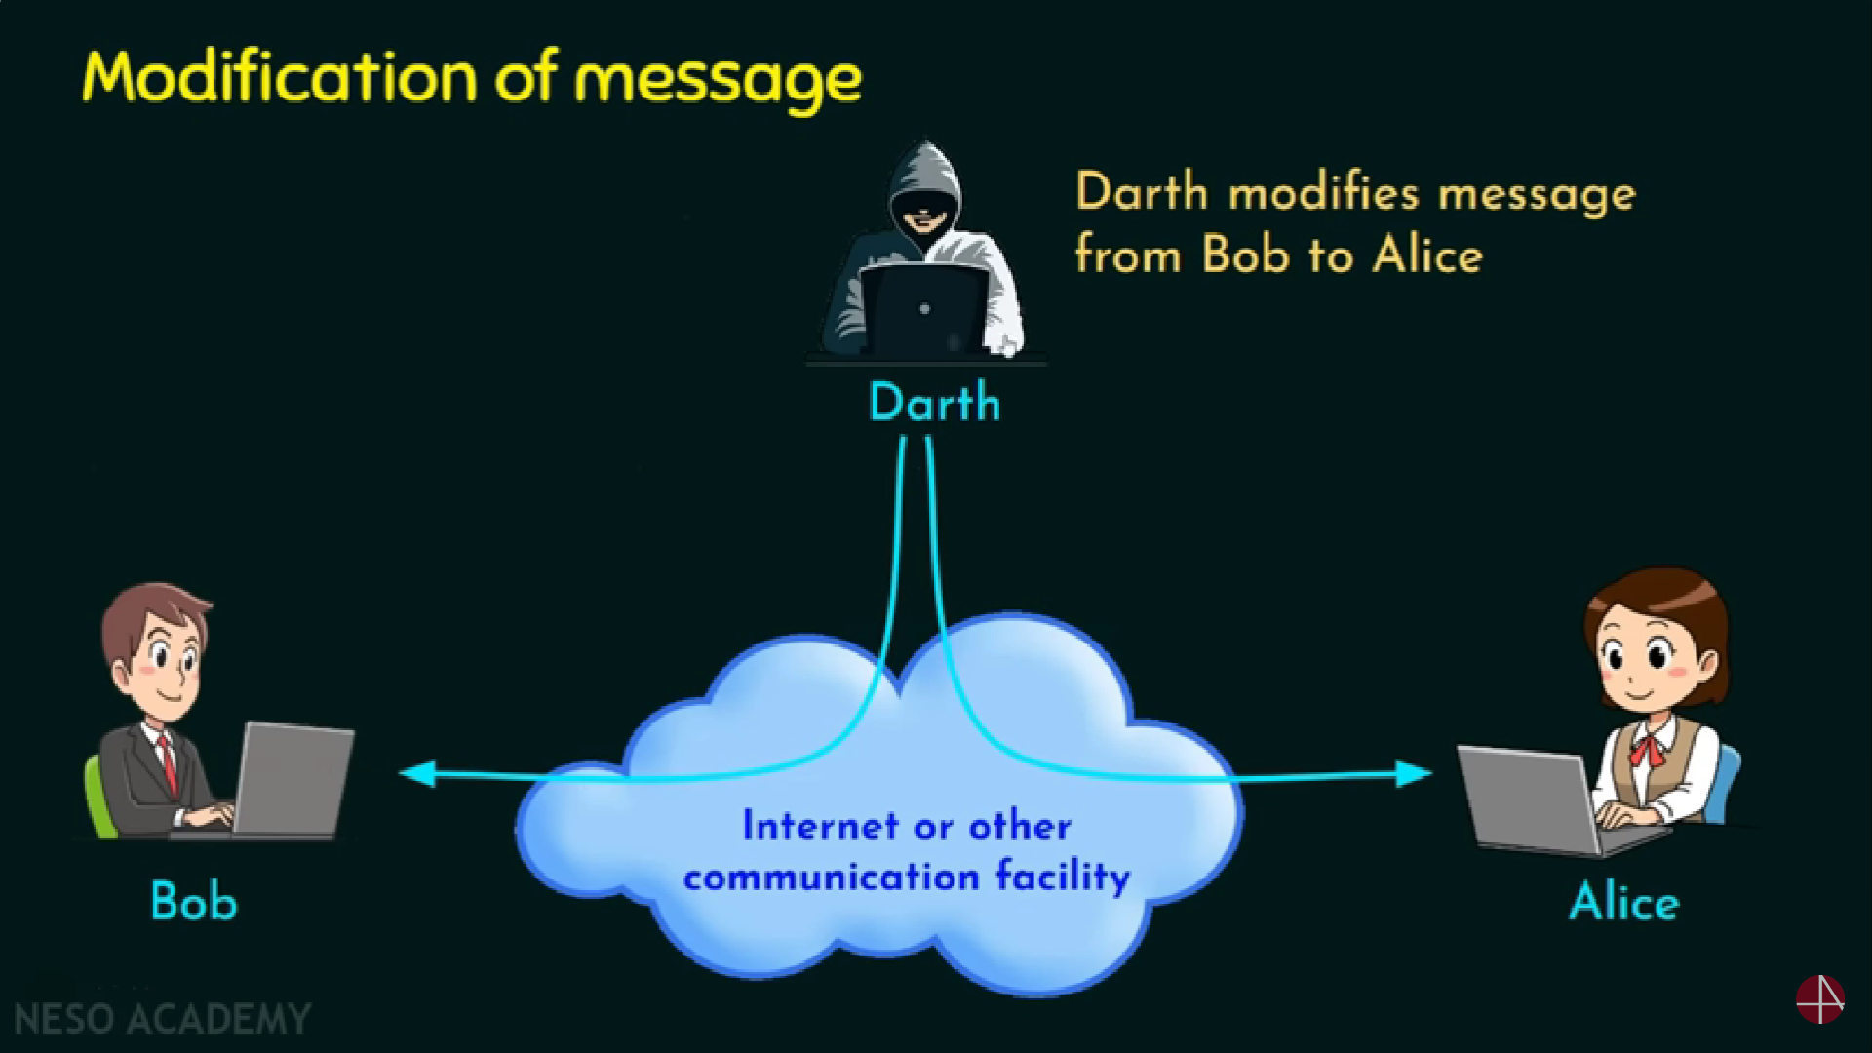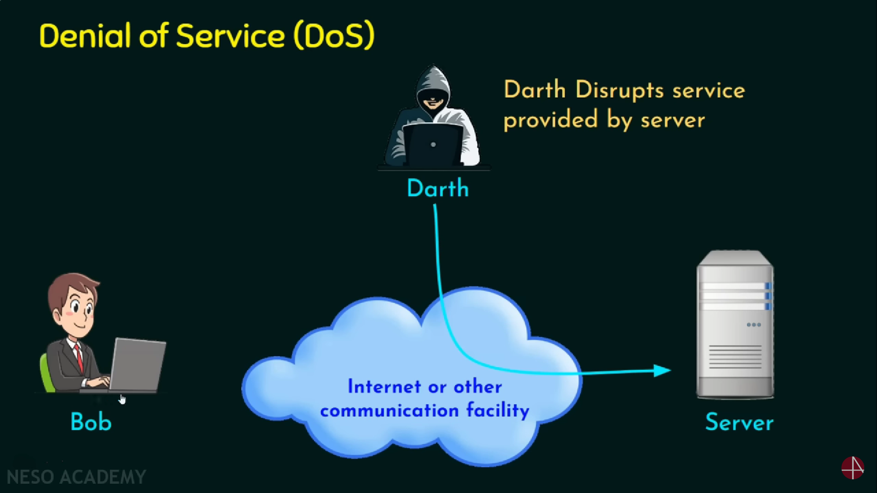

Passive attack vs active attack

Passive: Hard to detect

neither sender nor receiver is aware of the attack

encryption prevents the success of the passive attacks

more emphasis is on prevention than detection

Active : Hard to prevent

Physical , software and network vulnerabilities

Detect and recover from any disruption or delays

If the detection has a deterrent effect , it may also contribute to prevention

Security services : The processing or communication service that is provided by a system to give a specific kind of protection to system resources ; security services implement security policies and are implemented by security mechanisms

Authentication : Peer entity authentication and data origin authentication

Access control

Data confidentiality

Data Integrity

Non repudiation

Security mechanisms : Specific security mechanisms and pervasive security mechanisms

